**ACID Properties in DBMS**

DBMS is the management of data that should remain integrated when any changes are done in it. to maintain the integrity of the data, there are four properties described in the database management system, which are known as the **ACID** properties.

**ACID Properties**

The expansion of the term ACID defines for:

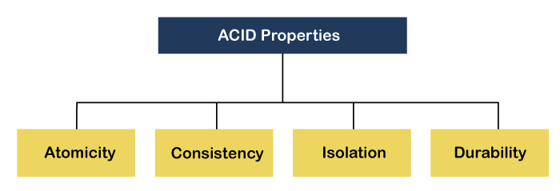

**1) Atomicity**

Atomicity in DBMS refers to the property of a database transaction where all the actions within the transaction are executed as a single, indivisible unit of work.it ensure that the transaction is either fully completed or fully rolled back to the state it was in before the transaction began.

**Real-life Examples of**

**Atomicity in DBMS**

* **Bank Transactions :** Banking transactions, such as withdrawals, deposits, and fund transfers, are some of the most common examples of atomicity in DBMS. When a customer initiates a transaction, the system ensures that all the steps within the transaction are executed successfully. If any step fails, the system rolls back the transaction to ensure that the database remains consistent.

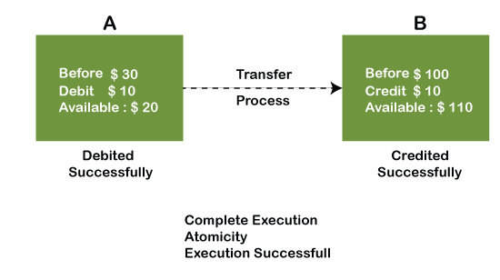

**2) Consistency :**

The word **consistency** means that the value should remain preserved always.

**Example:**

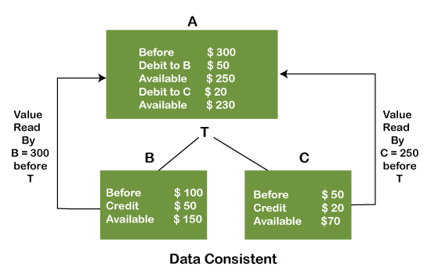

**3) Isolation**

The term 'isolation' means separation. In DBMS, Isolation is the property of a database where no data should affect the other one and may occur concurrently. In short, the operation on one database should begin when the operation on the first database gets complete.

**Example:** If two operations are concurrently running on two different accounts, then the value of both accounts should not get affected. The value should remain persistent. As you can see in the below diagram, account A is making T1 and T2 transactions to account B and C, but both are executing independently without affecting each other. It is known as Isolation.

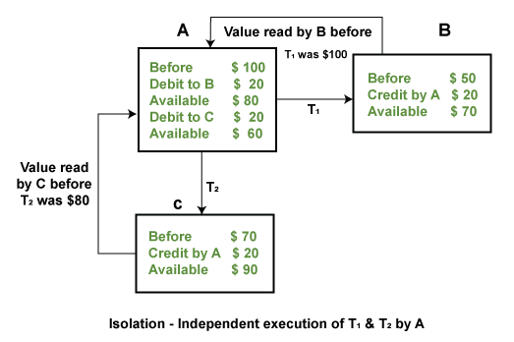

**4) Durability**

Durability ensures the permanency of something. In DBMS, the term durability ensures that the data after the successful execution of the operation becomes permanent in the database.

